Brahma Project

Luke Kennedy and Andrew Hopkins

# Design Diagrams

## Model Decomposition Diagram

## S:\CSSE 477\Brahma Project\Diagrams\Module Decomposition PNG.png

## S:\CSSE 477\Brahma Project\Diagrams\Dependency Diagram PNG.pngDependency Diagram

## Class Diagram

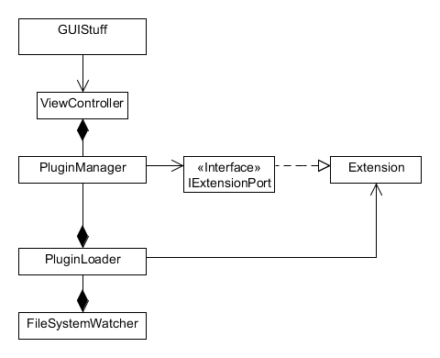

## Interaction Diagrams of Important Components

# S:\CSSE 477\Brahma Project\Diagrams\Interaction Diagram PNG.png

# Test Specifications

Our testing strategy for this project will be to utilized unit testing to verify the correctness and accuracy of the individual components and integration testing, using mocks, to show that our modules work together correctly.

# Code Repository

The code for this project can be found on Github at <https://github.com/LukeKennedy/freezing-hipster>.

# Quality Attributers

Extendibility: Our application allows users to create or find any plugin that supports our plugin architecture.

Usability: The app uses commonly understood user interface paradigms that will allow users to easily how to interact with the application. The application provides feedback for every user action.

Testability: Mock plugins may be injected into our plugin core to test the proper functionality of the host application. The PluginTimer can be tested using a mock plugin and JPanel.